MACH4METAL

metalworking machinery
Transito 21, 6909 DA Babberich, Netherlands
Tel. + 31 (0)316 – 247123
Fax. + 31 (0)316 - 247956
info@mach4metal.com
www.mach4metal.com
Bank No : 66.52.13.883
IBAN : NL33 INGB 0665 2138 83
BIC : INGBNL2A
VAT : NL 815393635B01

VICTOR VMC VCENTER 65
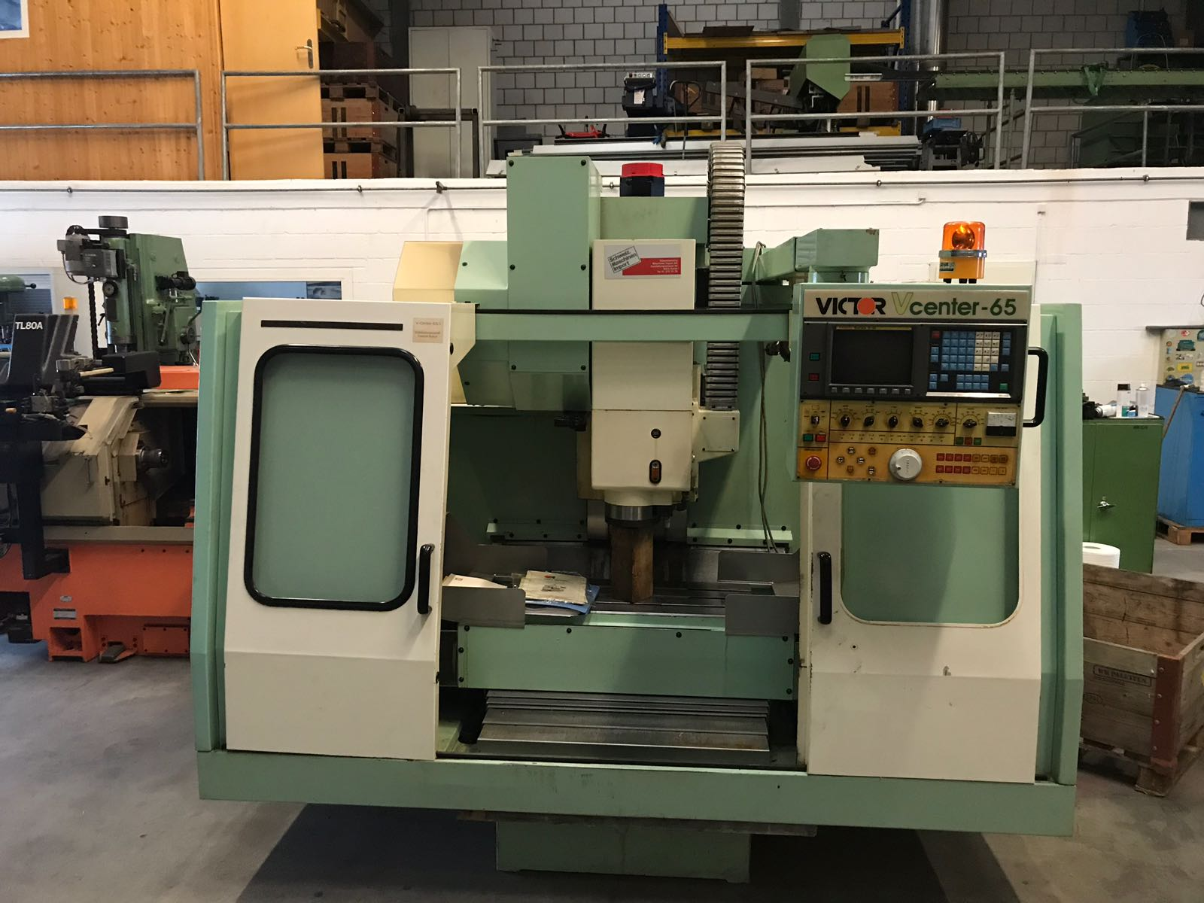
- Make : VICTOR Taiwan
- Type : Vcenter - 65
- Age : 1993
- Serial : 1424

- Capacity
- X travel : 650
- Y travel : 410
- Z travel : 510

- Table size
- Length : 900
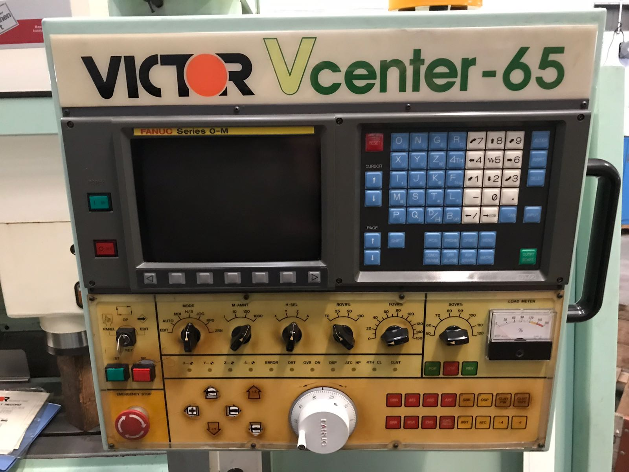
- Width : 410
- Load : 300
- Max spindle – table : 660

- Spindle taper : Bt 40
- Spindle speeds : 5.000
- Spindle power : 7.5 kW

- ATC Tool changer 30 positions
- Tool size Ø 76 x 300 x 6 Kg

- Rapid feed X / Y : 16.000 mm/M
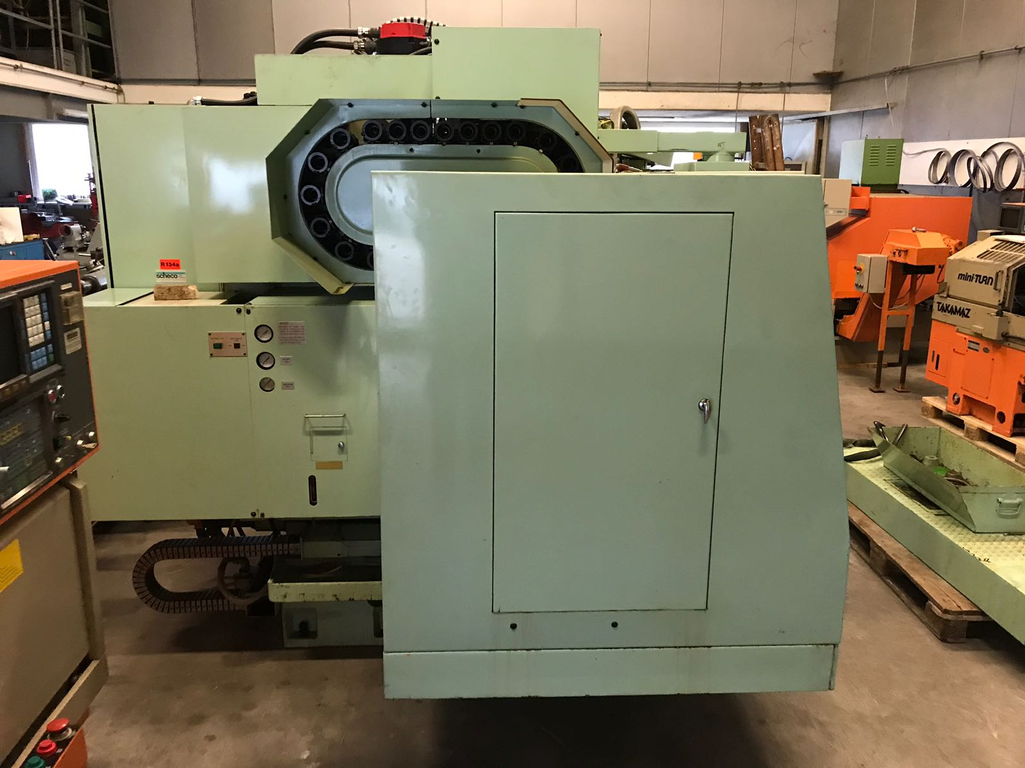
- Rapid feed Z : 12.000 mm/M

- Chip conveyor

- Dimensions
- Length : 2800
- Width : 2260
- Height : 2700
- Weight : 4500

Please Note: The above information has been obtained to the best of our ability and belief from, and from the manufacturers where possible. It is given in good faith, but its accuracy can not be guaranteed. Accordingly, it will not form a representation or constitute contractual terms. We advise you to check any vital details!

